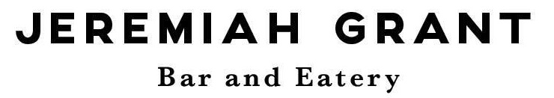
Function Room Charge
€100
No Charge if there is €1,000 spent between bar sales and finger food
Party Food
2kg of Finger Food
€90 Per Finger Food Platter
400g Hot Wings
400g Potato Wedges
400g Honey Mustard Cocktail Sausages
400g Vegetable Spring Rolls
400g Tandoori Chicken Skewers
Function Terms and Conditions:
Thank you for considering Jeremiah Grant for your function. The following terms and conditions must be adhered to prior to securing your function.
Confirmation: A booking is deemed confirmed when a deposit is paid and the terms and conditions are signed. Confirmation of numbers attending must be confirmed 7 days prior to function date. Charges for catering will be based on these confirmed numbers. If your numbers decrease once you have confirmed, you will be charged for the numbers confirmed. Any additional guest will be charged for accordingly.
Provisional Bookings: A provisional booking will be held for a period of seven days, after which time the booking will be released.
Food & Drink: Food & drink consumed on the premises must be bought on premises.
Deposits: Private functions will not be considered confirmed until €100 is received as a deposit. Deposits are non-refundable, if cancelled within 14 days of the event.
Payment: Payment must be paid in the full at the end of the function. We accept cash and all debit cards.
Decorations: Jeremiah Grant does not permit any decorations to be fixed to any surface of the building without prior approval from management. Confetti of any kind is not allowed under any circumstance.
Minors: Children under the age of 15 must leave the premises by 9pm. Children aged between 15-17 years may remain on the premises after 9pm where they are attending a private function at which a substantial meal is served with pre-approval by management.
Compliance: Jeremiah Grant practices the responsible service of alcohol. Patrons that deem to be intoxicated will be refused service and requested to vacate the premises. Jeremiah grant has a strict proof of age policy. No ID = No entry. Proof of age card, passport and driver’s license, are the only acceptable proof of identification.
Damage: The client is financially responsible for any damage caused to the premises by themselves or their guests
Dress Codes: Smart, neat, casual dress is required at all times to enter the venue. It is the responsibility of the host/client to advise their guests of the dress code.
Liability: Jeremiah Grant does not accept any responsibility for loss or damage of property, left in the venue, prior to, during, or after an event.
Equipment: Any equipment belonging to an external band or DJ must be taken with them on the night unless prior approval from management has been made.
I have read, understood and agreed to Jeremiah Grant terms and conditions.
Signed by the client:__________________________
Full name in print:____________________________
Date: _______________

